8

Sample Participant Enrollment Form
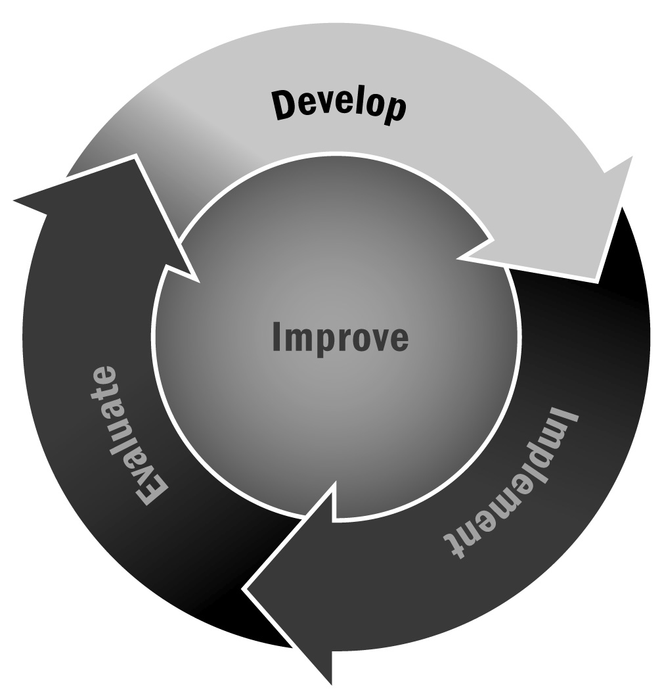
In Chapter 1, you learned that a key part of your recruitment process is creating a clear way for youth to enroll in your program. All new participants should complete a program enrollment form that asks, at a minimum, for things like name, address, and family member contact information, and provides opportunities for families to sign various permission forms.
Directions: Use or adapt this form for your program. If you are using a printed form, consider printing it on your program’s letterhead or brightly colored paper. If you have a website, consider creating an online enrollment form.

Youth Information
Participant’s Name (please print):
Gender: |  |  |  |  |  |  | Date of Birth:
School:
Mailing Address:
City: |  |  |  |  |  |  |  |  |  |  | State: |  | Zip Code:
Home Phone:
Primary Language Spoken at Home:
Grade: |  |  |  |  |  | Teacher Contact:
Description of Your Child
Please tell us about your child. Describe his or her interests, hobbies, extracurricular activities, and anything else that will help us get to know your child better.

Family Information
Family Member Name:
Mailing Address:
City: |  |  |  |  |  | State: |  | Zip Code:
Phone No(s).: |  |  |  |  | Email:
Family Member Name:
Mailing Address:
City: |  |  |  |  |  | State: |  | Zip Code:
Phone No(s).: |  |  |  |  | Email:

Transportation
I (or someone I designate) will pick my child up from program.
Name of Person and Alternate:
My child will take the bus (or other provided transportation home) after the program ends.
My child will walk home alone from the program.
Other:
Health Release
I give permission for the activity leader in charge to act on my behalf to take measures he or she deems necessary in the event of sickness or injury during the field trip. I agree to pay for any medical expenses for my child whose name appears above.
Current medical conditions
(including allergies) or medication:
Insurance Company:
Policy No.: |  |  |  |  | Policyholder’s Name:
Signature: |  |  |  |  |  | Date:
Permissions
Please indicate below whether you give permission for the following things:
- The program to take and use photos of your child for the purpose of promoting the program (e.g., on our website, in program brochures)
Yes No
- The program to survey your child occasionally in order to improve the program (Note: Any survey that is part of a research study or for any purpose other than program improvement will have a separate permission process. This is just for program improvement information.)
Yes No

